**School of Electrical and Electronic Engineering**



Embedded Systems Project

DESIGN REPORT #1

Title: ?

Group Number: ?

|  |  |  |
| --- | --- | --- |
| Group members name: | ID Number | I confirm that this is the group’s own work. |
|  |  |  |
|  |  |  |
|  |  |  |
|  |  |  |
|  |  |  |

Tutor: Click here to enter text.

Date: Click here to enter a date.

Contents

1. Introduction 1

2. Motor characterisation 1

2.1. Armature Resistance 2

2.2. Torque Constant 3

2.3. Back EMF Constant 3

3. Load measurements 5

4. Gear ratio selection 5

5. Summary 5

6. References 5

# Introduction

* See the chapter on Reports (near the start of the ESP Procedures Handbook).
* See the specific marking scheme for this section of the report.

You may want to reference books and papers that you have researched. Give their reference like this [1] (see the References section at the end of this document).

# Motor characterisation

In order to design an effective drivetrain for the buggy and algorithm to control the movement, the characteristics of the motor will need to be analysed. These series of experiments are designed to help find the resistance of the motor, speed under load and torque outputted. The selected motor is a brushed permanent magnet motor, typically around 70% efficiency [?]. Due to low efficiency, this motor would be prone to generate thermal energy, causing its resistance to increase, lowering the effective output of torque and speed. The following tests are designed to identify these thresholds and aid the decision of picking. Using the results obtained in the stress tests, the values to the load measurements sections can be compared, allowing the group to reach an agreement on a gear ratio that would be the most effective to our design.

The maximum potential difference across the motor will be between 3 and 5 volts. These test values will be used to design a motor driver board for the buggy that will be programmed and configured to control each motor independently. In addition, the current must be enough to overcome the stall position of the buggy and go up through the ramp on the race day.

To calculate the armature resistance, the motor was stalled, applying a start voltage of 1 volt and a protection current limit of 1.7 amps, measurements were taken increasing each time 0.25 V until the current limit was reached. Then, using the EMF equation:

$$V=K_{E}ω+IR+V_{b} \left(2.1\right) I=\frac{V-V_{b}}{R}-\frac{K_{E}ω}{R} (2.2)$$

Where $K_{E}ω=0$, i.e. motor is stalled;

$$I=\frac{V-V_{b}}{R} (2.3)$$

Where current is equal to equal to the difference of EMF of power supplied and potential difference across the commutator brush. The current is therefore the potential difference across the motor divided by the internal coil resistance of the motor.

## Armature Resistance

**Fig. 2.1 A graph comparing the linear relationship of how the voltage across the motor varies by varying the flow of current for stalled and high torque stalled experiments.** Despite using the same motor and effective method, two separate armature resistance values are occurring. The high torque experiment gives us a shallower gradient; therefore, the resistance value is around 2.0136Ω. Starting at the highest voltage for high torque, the motor would have been operating at a cooler temperature resulting in lower internal resistance. By getting to the stall voltage region, the motor would have been warmer. The opposite is true for the non-high torque experiment where the experiment was started with low voltage. The effective armature resistance would be:

Stalled

$$\frac{R_{stall}+R_{ht}}{2} \left(2.4\right) \frac{2.0136+2.4211}{2}=2.2174 Ω$$

With a percentage error of:

$$\frac{2.4211- 2.0136}{(2.0136+2.4211)÷2} ×100=18.377\% (2.5)$$

## Torque Constant

Motor spinning

Motor stalled

**Fig. 2.2 A graph comparing the torque output of the motor when varying the current across the motor.** The blue line shows the output while the motor is spinning. Due to the gradient compared to the stalled motor is higher, a higher KT is generated. Higher KT signifies that a greater amount of torque can be created with the same amount of current as the red line. The red line however shows a more realistic KT constant where it a greater resistance is placed on it causing a stall.

$$K_{T}= \frac{T_{max}}{I_{max}- I_{stalled}} (2.6)$$

The torque constant is defined as the rate of change of torque with respect to the current supplied to the motor. An important point to note is that the motor requires a minimum current flow through the coils in order to produce movement thus torque. This therefore explains why the graph line is slightly offset to the right. In this scenario, the stall current is around 0.16A but it must be noted that the stall current is dependent on a wider range of factors directly related to the buggy.

## Back EMF Constant

**Fig 2.3 A graph comparing how varying the speed of the spin of the motor affects the back EMF voltage.** The gradient of this line defines the back EMF constant. This is characteristic is generated due to the motor creating an independent electromotive force that is applied opposite to the electromotive force of the power supply. This must not be mistaken for the potential difference lost due to the internal resistance of the coils itself.

ω $=\frac{V_{E}}{K_{E}}$ **(2.7) $K_{E}= \frac{V_{E}}{ω}$ (2.8)**

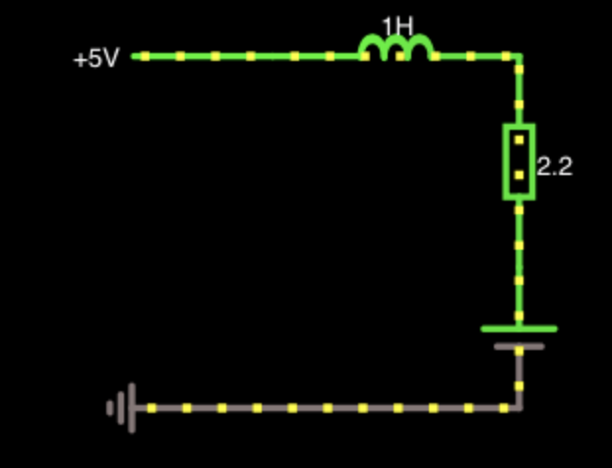

**Fig 2.4 A basic simulation showing the effect of back EMF and how it affects the flow of current across the motor.**

By calculating and knowing the back EMF constants, these values can be used to create basic simulations that will show the team the effects of varying resistances and electromagnetic force supplied by the batteries.

|  |  |
| --- | --- |
| Torque Constant spinning (Nm/A) | 0.008 |
| Torque Constant stalled (Nm/A) | 0.0069 |
| Armature Resistance ( $Ω)$ | 2.217 |
| Back EMF Constant (V/rads-1) | 0.0096 |

**Table 2.1 Summary of motor constants.**

# Load measurements

* See the chapter on Reports (near the start of the ESP Procedures Handbook).
* See the specific marking scheme for this section of the report.

# Gear ratio selection

* See the chapter on Reports (near the start of the ESP Procedures Handbook).
* See the specific marking scheme for this section of the report.

# Summary

* Design recommendations
* Summary of key results and assumptions.

# References

1. See the section on Citations and Referencing Styles in the ESP Procedures Handbook.

Make sure that you have **read the top** of the marking scheme to look for report length etc.

Make sure that you have **read the bottom** of the marking scheme for Presentation and Penalties.

Remember to update your table of contents before submitting the report.

Aim to submit the report long before the deadline, to mitigate last minute problems with the internet and with Blackboard.